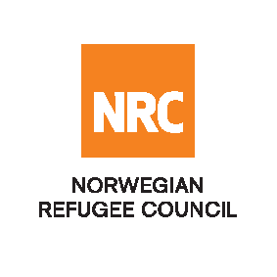

**INVITATION TO TENDER**

The Norwegian Refugee Council (NRC) is a non-governmental, humanitarian organization with 75 years of experience in helping to create a safer and more dignified life for refugees and internally displaced people. NRC advocates for the rights and provides assistance, protection and durable solutions to refugees and internally displaced persons worldwide.

NRC has been operating in Nigeria since late 2015 providing assistance with Emergency shelter, Livelihoods and Food Security, Water, Sanitation and Hygiene sectors, Information Counseling and Legal Assistance, Camp Management and Education.

Norwegian Refugee Council (NRC) invites bids from competent service providers in Nigeria for the following services:

|  |  |  |
| --- | --- | --- |
| **Internal Reference** | **Tender Category** | **Closing date** |
| 19/NRC-NAT/NG/2025 | Consultancy for Labor Market Assessment (LMA) in Maiduguri Metropolitan Council (MMC) and Jere LGAs) and Adamawa State (Fufore, Yola South and Madagali LGAs) | 20th April 2025 |

**Application procedure**

All interested are requested to request to submit their curriculum vitae along with other required documents listed below to the following email and as per the detailed tender document to: [**ng.tenders@nrc.no**](mailto:ng.tenders@nrc.no)**.**

The application should be titled: **“19/NRC-NAT/NG/2025 – “Consultancy for Labor Market Assessment (LMA) in Maiduguri Metropolitan Council (MMC) and Jere LGAs) and Adamawa State (Fufore, Yola South and Madagali LGAs)”** in the e-mail subject.

**The deadline for submission 20th April 2025 at 5:00 p.m. Nigeria Time.** Failure to meet the closing date will result in the bid being rejected. Only short-listed/successful candidates will be contacted.